49W Frameless BLDC Motor
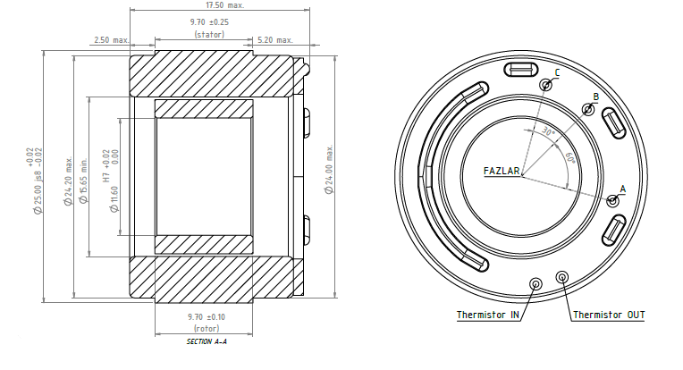
Basic Motor Parameters
Rated Power | W | 49
Rated Speed | rpm | 7300
Rated Torque | Nm | 0.065
Rated Current | A | 5.5
Rated Voltage | V | 12
No-Load Speed | rpm | 10500
Max. Efficiency | % | 90
Electrical Parameters
Number of Phases |  | 3
Number of Poles |  | 14
Torque Constant (KT) | Nm/A | 0.0118
Back EMF Constant (KE) | Vs/rad | 0.0109
Terminal Resistance Phase to Phase (±%10) | mΩ | 375
Terminal Inductance Phase to Phase (±%30) | mH | 85
Thermal Data
Ambient Temperature | °C | -40...+85
Max. Winding Temperature | °C | +155
Physical Parameters
Outer Diameter | mm | 25
Shaft Diameter | mm | N/A
Max. Lenght | mm | 17.5
Weight | gr | 30
Motor Connection
U | A
V | B
W | C
Sensor Connection
N/A | N/A
Connector Articles
Power | N/A
Signal | N/A

